## Day 1 : 03/01/2022,Monday

**Topic**: Create your salesforce developer org to get started

**Milestone / Activities**: Creating Developer Account

Account activation

Login to your salesforce Account

**Detailed Description**: First I sign up the developers.salesforce.com with all required information, after clicking the sign up button I will get an email for activating the developer account ,then I verify the account ,then after I login the salesforce account.

Upload the Screenshot the Milestone / Activities:

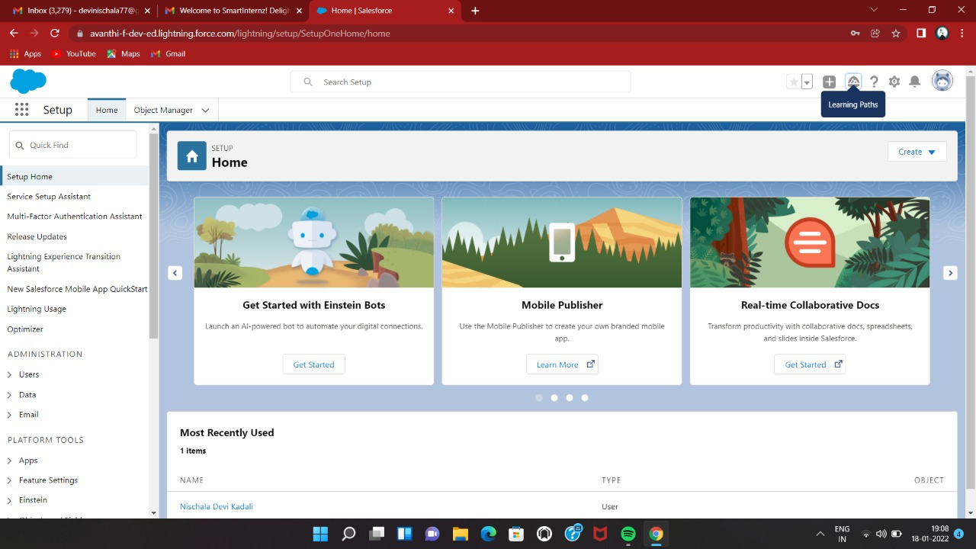

**Day 2 : 04/01/2022,Tuesday Topic**: Custom Object Creation.

**Milestone / Activities**: Create the custom objects for the application.

Create fields on college object.

Create fields on application form object. Create fields on student object.

Create fields on subject object.

**Detailed Description**: First I have created the custom objects then after I created all the fields in College,Application form,Student and Subject objects according to the project details.

Upload the Screenshot the Milestone / Activities :

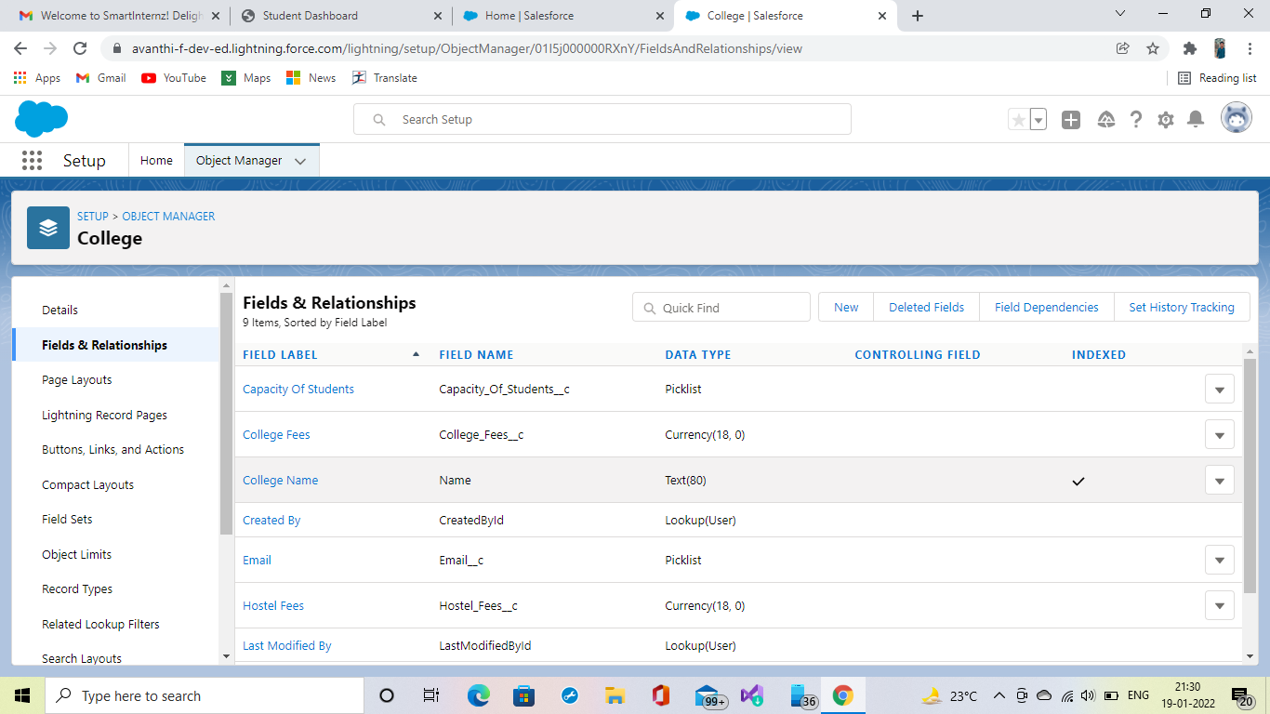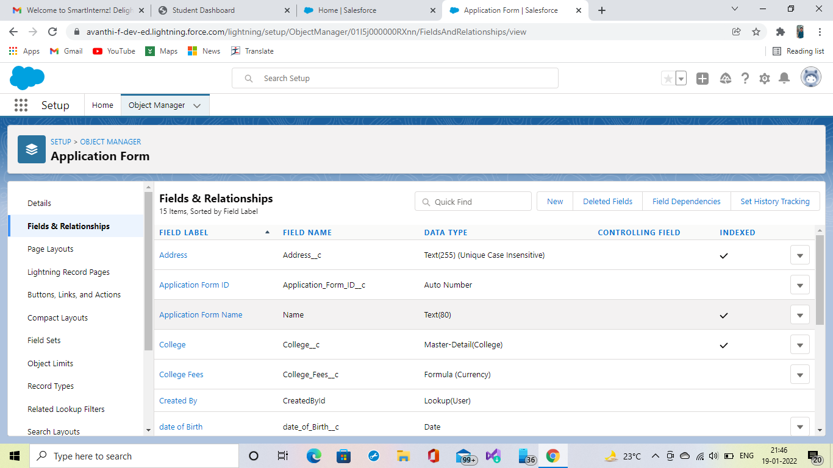

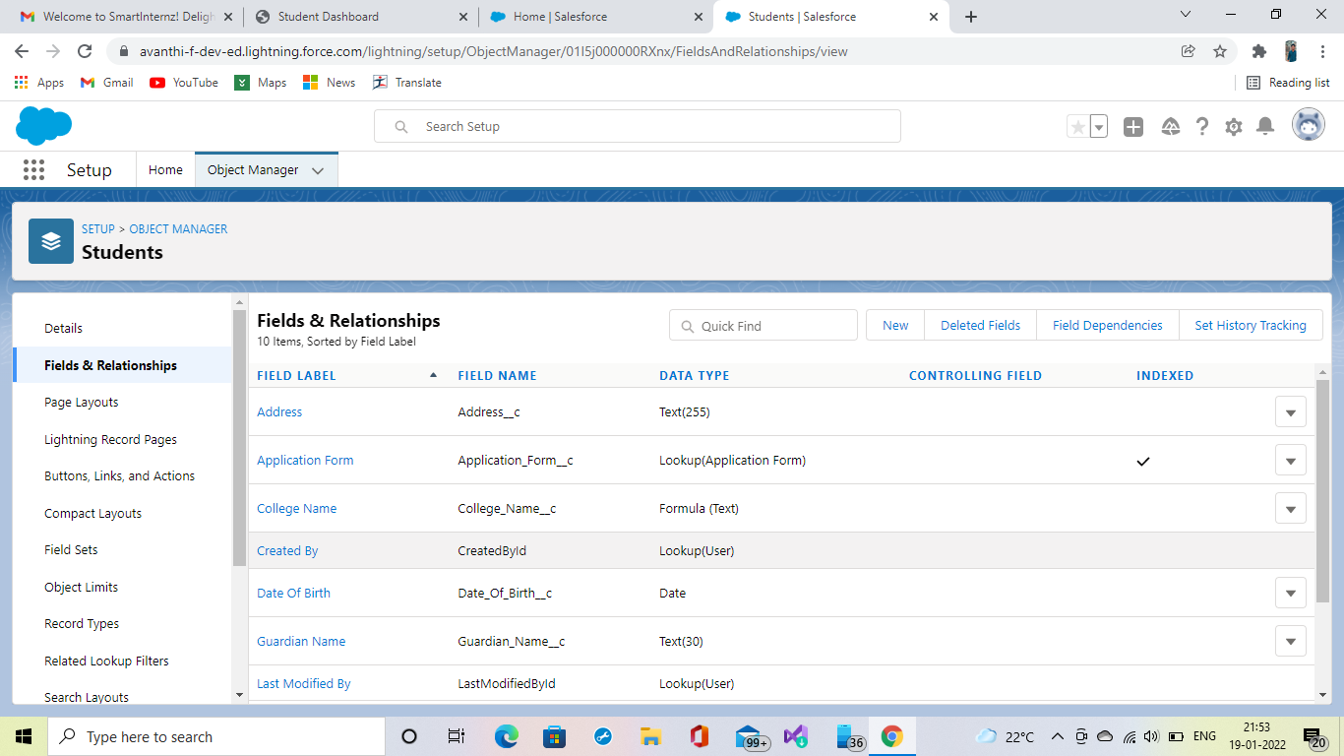

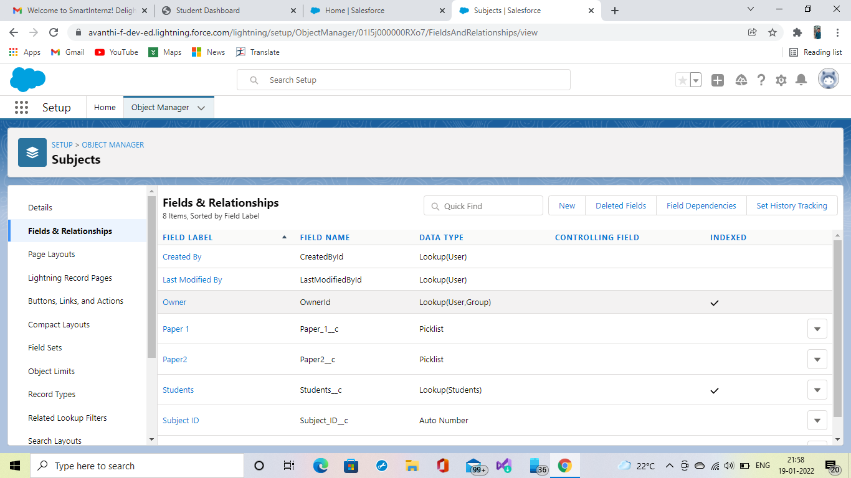

## Day 3 : 05/01/2022

**Topic: Adding Business Logic to Application**

**Milestone / Activities**: Creating Global Picklist value sets

Creating Field Dependencies

Create Validation Rule on College Object Process Automation

**Detailed Description**:First I have created global picklist value sets Setup>Quick Find box>picklist value sets>new then I have created field dependencies ,setup>object manager>college>field and relationship>field dependencies>new then I have created validation rule , setup>object manager >college>validation rule>new then after I have created builder named Application Form Process master setup>quick find box>process builder>new,created as per information given in project details

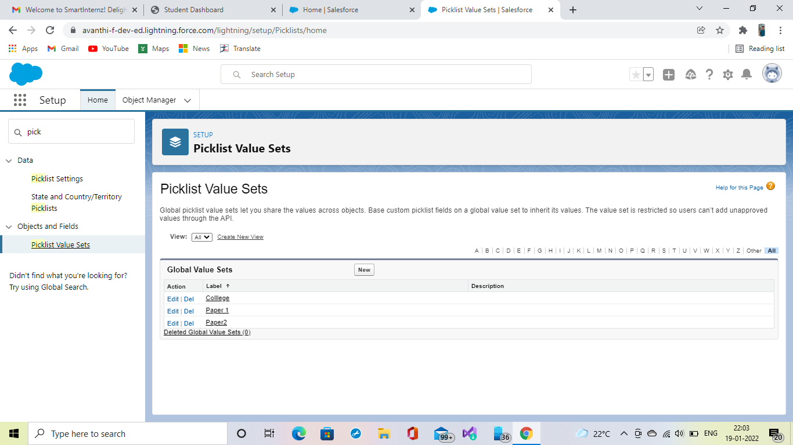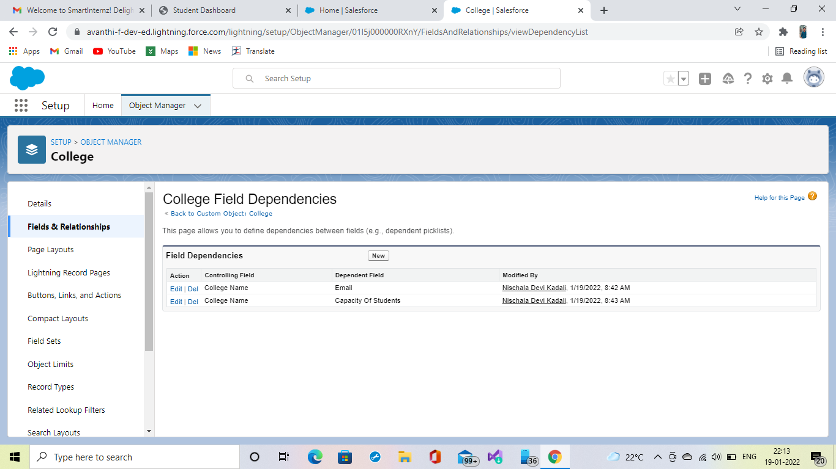

## Day 4 :06/01/2022 Thursday Topic: Process Builder.

**Milestone / Activities: Process Automation.**

**Detailed Description:** I Have Created Builder Named Application Form Process Master Setup>Quick Find box>process builder >New, Created as per information given in the project detail.

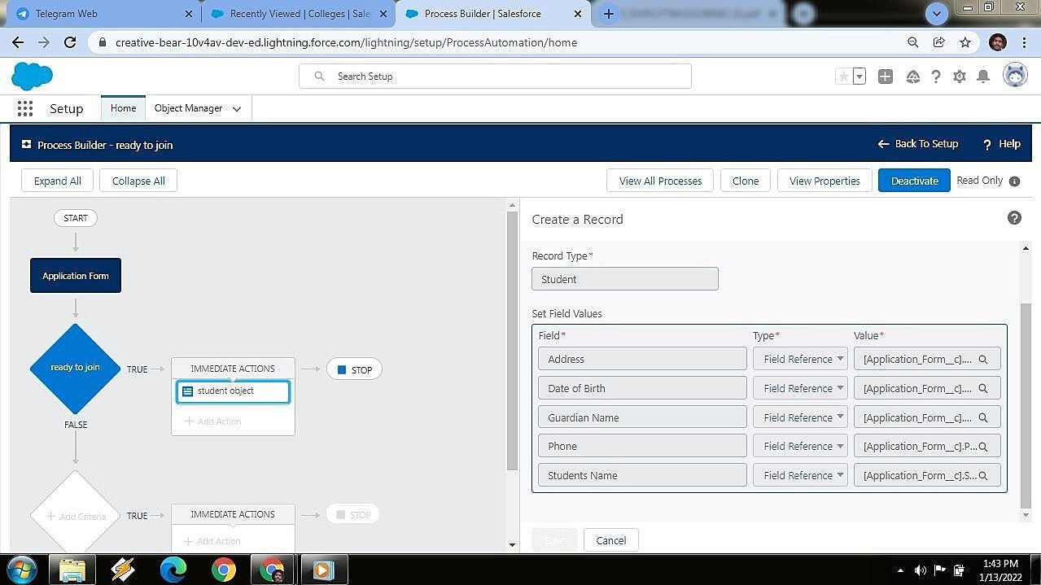

## Day 5 :07/01/2022 Friday Topic: Flows

**Milestone / Activities: Create a student record using Flows.**

**Detailed Description:** I have Created the application form record trigger flow, in that I have created a variable named in student in the resource section and I add the some assignments and then created the student record.

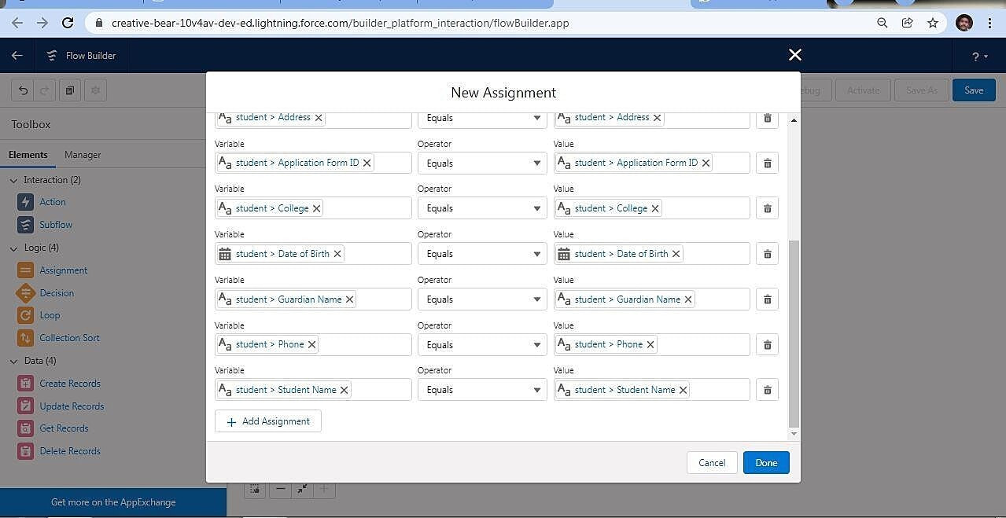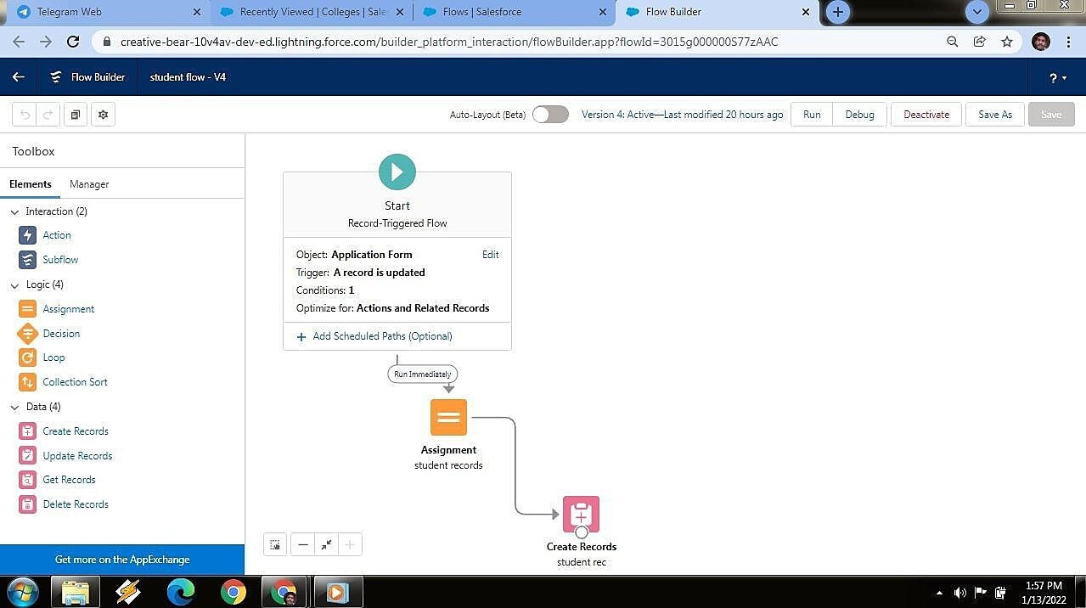

## Day 6 :10/01/2022 Monday

**Topic: Batch Apex**

**Milestone / Activities: Create A Batch Apex for Application Form**

**Detailed Description:** I have created batch apex for a application form. In that I have to create one apex class named as Application batch test. I wrote code in that apex class and checked the errors in JAVA script then execute the code.

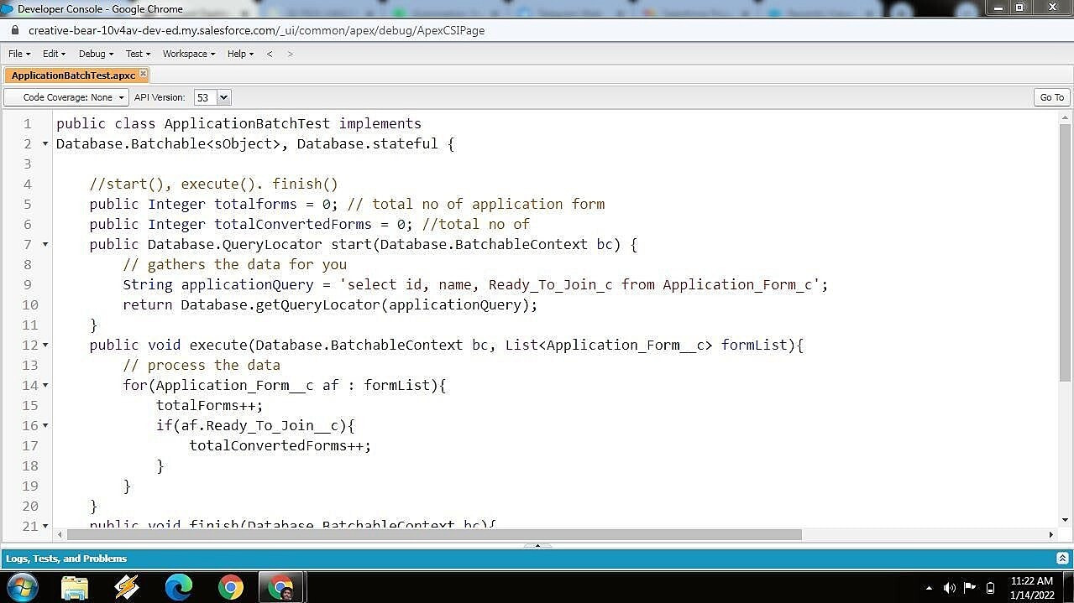

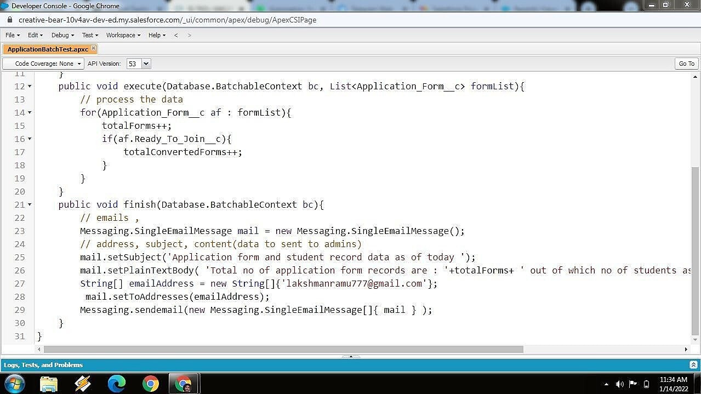

## Day 7 :11/01/2022 Tuesday Topic: Batch Apex

**Milestone / Activities: Create A Schedule class**

**Detailed Description:** I have created batch apex for a schedule class. In that I have to create one apex class named as Application schedule. I wrote code in that apex class and checked the errors in JAVA script then execute the code.

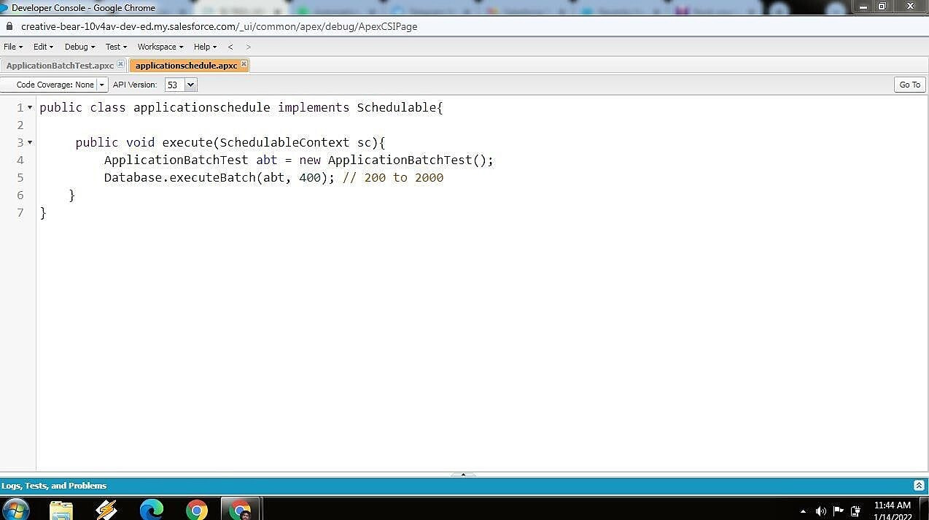

# *Day 8 : 12/01/2022,Wednesday.*

**Topic:** Lightning Web Components.

**Milestone / Activities :** Create College Data Table Component

**Detailed Description :** I have created a apex class for creating the College Data Table.

-> Developer Console -> New -> Apex Class -> Enter Code -> Save.

## Upload the Screenshot of the Milestone / Activities :

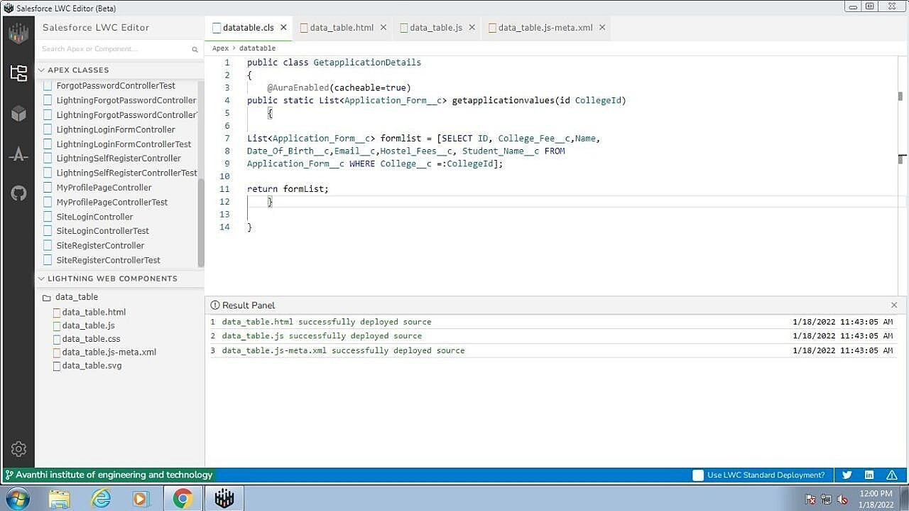

***Day 9 : 13/01/2022,Thursday.***

**Topic:** Lightning Web Components.

**Milestone / Activities :** Create College Data Table Component (HTML File).

## Detailed Description :

-> I have created the HTML File for the College Data Table as follows :

-> App Launcher -> College Management -> Colleges -> Adding Lwc Extension -> Open Lwc Editor -> Create HTML File -> Save.

## Upload the Screenshot of the Milestone / Activities :

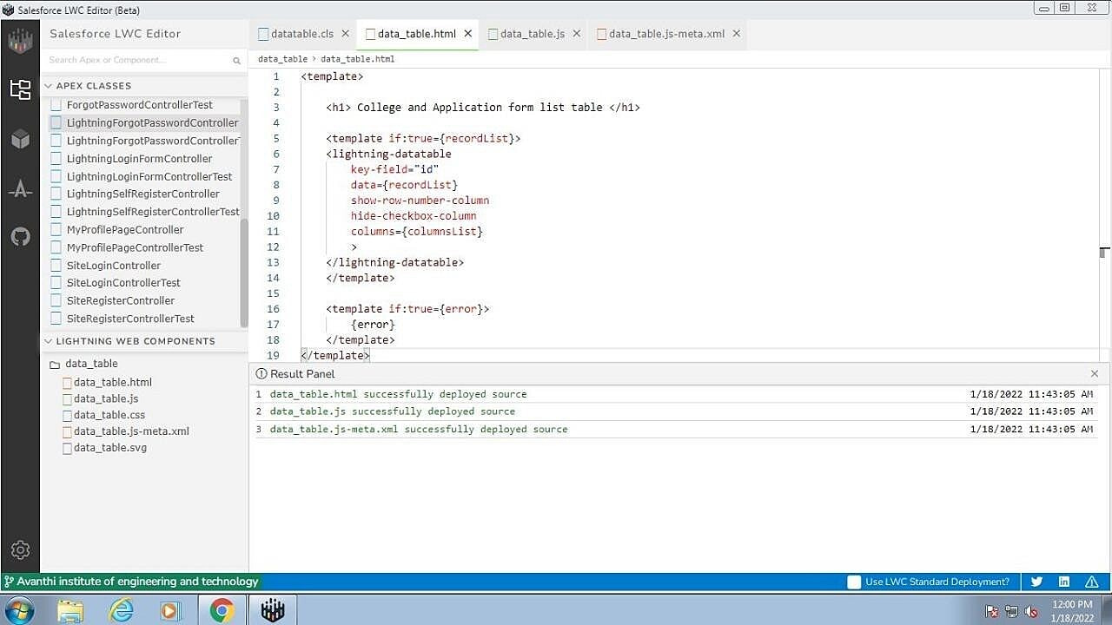

***Day 10 : 14/01/2022,Friday.***

**Topic:** Lightning Web Components.

**Milestone / Activities :** Create College Data Table Component (JAVA Script File).

## Detailed Description :

-> I have created the JAVA Script File for the College Data Table as follows :

-> App Launcher -> College Management -> Colleges -> Open Lwc Editor -> Create JAVA Script File -> Save.

## upload the Screenshot of the Milestone / Activities :

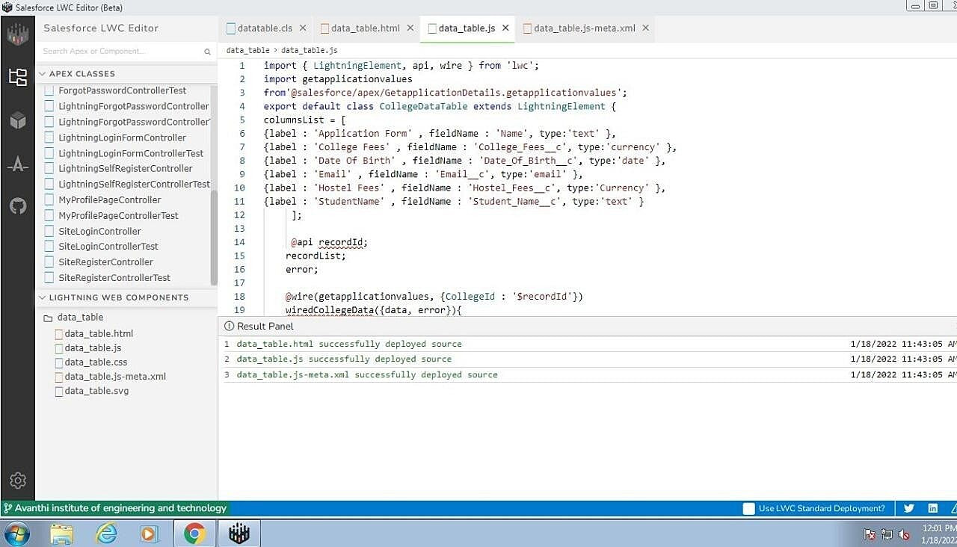

***Day 11 : 17/01/2022,Monday.***

**Topic:** Lightning Web Components.

**Milestone / Activities :** Create College Data Table Component (Meta File).

## Detailed Description :

-> I have created the Meta File for the College Data Table as follows :

-> App Launcher -> College Management -> Colleges -> Open Lwc Editor -> Create Meta File -> Save.

## Upload the Screenshot of the Milestone / Activities :

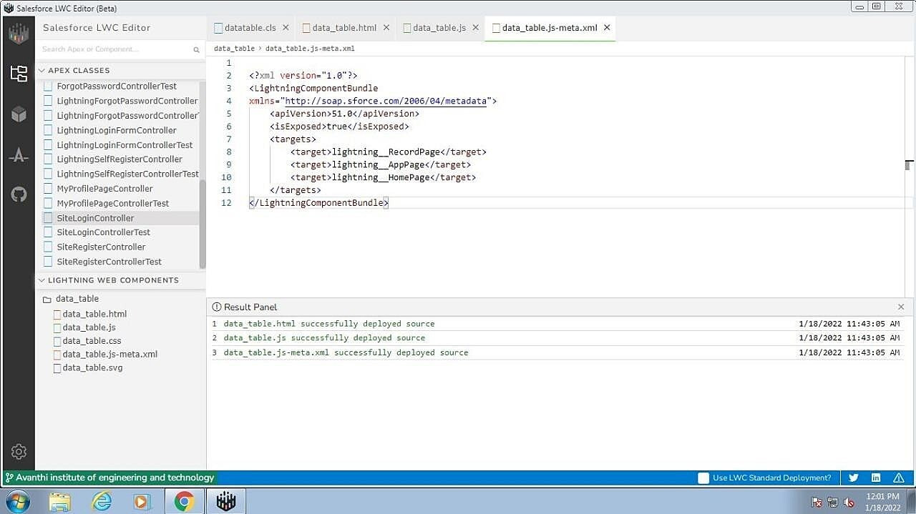

***Day 12 : 18/01/2022,Tuesday.***

**Topic:** Lightning Web Components.

**Milestone / Activities :** Create Data Table Tab in the Lightning app page.

## Detailed Description :

-> I have created the Data Table in the Lightning app page by adding new lightning component to the new Tab

-> App Launcher -> College Management -> Colleges -> Edit Page ->

Add New Tab -> Light Components -> ClgTable -> Save.

## Upload the Screenshot of the Milestone / Activities :



